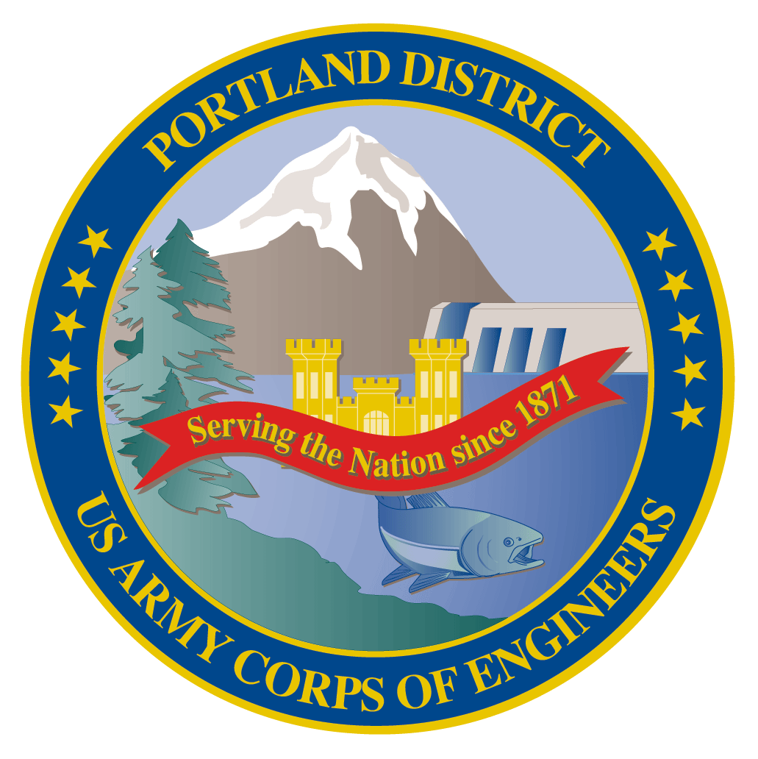
Fish Facility Design Review Work Group (FFDRWG)

USACE, Portland District

April 2021 Updates
April 1, 2021

Introductions
FFDRWG members:
BPA
Scott Bettin
Kim Johnson
Siena Lopez-Johnston
Christine Petersen
Greg Smith
Leah Sullivan
NOAA
Blane Bellerud
Gabriel Brooks
Trevor Conder
Kinsey Frick
Claire McGrath
Josie Thompson
Logan Negherbon
USFWS
Dave Swank
States
Erick Van Dyke (ODFW)
Charles Morrill (WDFW)
CRITFC/Tribes
Tom Lorz (CRITFC)
Blaine Parker (CRITFC)
Tom Skiles (CRITFC)
Casey Baldwin (CTCR)
Michael Karnosh (CTGR)
Lawrence Schwabe (CTGR)
Torey Wakeland (CTGR)
Aaron Jackson (CTUIR)
Ralph Lampman (YN)
NPCC
Leslie Bach
Kris Homel
FPC
*Erin Cooper
PSMFC
Alan Brower
Darren Chase
Roger Clark
Mark Leonard
Scott Livingston
Nicole Tancreto
Don Warf
CENWD
Doug Baus
Tim Dykstra
Dan Feil
Mike Langeslay
Cindy Studebaker
Sean Tackley
Lisa Wright
CENWW
Karl Anderson
Chris Peery
Marvin Shutters
Denise Griffith
CENWP-OD
Leif Halvorson
Ben Hausmann
Rebecca Cates
Jeanette Wendler
Bob Cordie
Jeffrey Randall
Scott Fielding
Eric Grosvenor
Michael Lotspeich
Erin Kovalchuk
Tammy Mackey
Darren Gallion
Nathan McClain
Robert Wertheimer
CENWP-PM
Jim Adams
Eric Bluhm
Ian Chane
Andrew Derugin
Jeff Hicks
Valerie Higdon
Steve Sipe
Bob Winters
Brad Eppard
David Griffith
Fenton Khan
Rachel Laird
Jake Macdonald
Rich Piaskowski
Jon Rerecich
Ida Royer
David Trachtenbarg
Jeremiah Woodard
CENWP-ENC
Adam White
Brandt Bannister
Bridget Bell
Jonathon Brink-Roby
Shari Dunlop
Laurie Ebner
Curtis Lipski
Chris Motti
Stephen Schlenker
Max Wilson-Fey

Action items from last meeting
- Jon Rerecich (NWP) will prepare a MOC for operations during testing and FPP deviations
  - Still pending.
- Shari Dunlop (NWP) will invite Don Warf (PSMFC), Gabriel Brooks (NOAA), and Logan Negherbon (NOAA) to the project kickoff meeting
  - Scoping meeting between USACE, PSMFC, and NOAA occurred on 3/15. Introductions were made and PSMFC/NOAA will be funded to contribute to the design process.

Written project updates
- JDA North Fish Ladder Variable Width Weir improvement – Eric Bluhm (PM), Eric Grosvenor (JDA), Jacob Macdonald (FC)
- JDA North Fish Ladder LPS water supply upgrade – Eric Bluhm (PM), Adam White (TL), Jacob Macdonald (FC)
- JDA turbine rehab – Steve Sipe (PM), Curtis Lipski (TL), Jon Rerecich (FC)
- TDA AWS Trash Rake – Ida Royer (PM), Erica Tarbox (TL), Ida Royer (FC)
- BON spillway rock removal [prevention] – Jeremiah Woodard (PM), Max Wilson-Fey/Chris Motti (TL), Ida Royer/Andrew Derugin (FC)
- BON LPS pump upgrades – Bob Winters (PM), Ben Hausmann (TL), Andrew Derugin (FC)
- BON Cascades Island LPS flume modifications – Bob Winters (PM), Ben Hausmann (TL), Andrew Derugin (FC)
- BON minor adult lamprey passage improvements – Bob Winters (PM), Ben Hausmann (TL), Andrew Derugin (FC)
  - Cascades Island upper leads
- BON Washington Shore control section redesign – Bob Winters (PM), Shari Dunlop (TL), Andrew Derugin (FC)

New and upcoming project introductions
- BON Bradford Island Ladder extensive minor modifications to serpentine section for lamprey – Bob Winters (PM), Adam White (TL), Andrew Derugin (FC)
- BON Bradford Island B-Branch entrance improvements (variable width entrance weir, bollards, and transition pool LPS) – Bob Winters (PM), Adam White (TL), Andrew Derugin (FC)
- BON Washington Shore transition pool LPS – Bob Winters (PM), Adam White (TL), Andrew Derugin (FC)
- TDA East Fish Ladder transition pool LPS – Eric Bluhm (PM), Adam White (TL), Jacob Macdonald (FC)
- TDA East Fish Ladder control section weir modifications for lamprey – Eric Bluhm (PM), Adam White (TL), Jacob Macdonald (FC)
- JDA South Ladder entrance improvements (rounded crest, slot filler) – Eric Bluhm (PM), Adam White (TL), Jacob Macdonald (FC)

Next meeting: May 6th @ 09:00

Fish Facility Design Review Work Group (FFDRWG)

USACE, Portland District

Project Update
Date Prepared/Updated: 2021-03-30

JDA North Fish Ladder Variable Width Weir Improvement
Project Identifier: | P2 # 492402
Project Manager (PM): | Eric Bluhm (CENWP-PM-FP)  Eric.V.Bluhm@usace.army.mil
Technical Lead (TL): | Eric Grosvenor (CENWP-ODJ)  Eric.Grosvenor@usace.army.mil
FFDRWG Coordination (FC): | Jacob Macdonald (CENWP-PME)  Jacob.Macdonald@usace.army.mil

Project Description
Replace the skin on the downstream face of the JDA North Fish Ladder Variable Width Weir (VWW) with material that will provide a smooth attachment surface for lamprey. The VWW was originally constructed in 2013 using HDPE panels on the downstream face, either to save weight or cost. Some HDPE panels have since failed and were temporarily replaced with screen material.
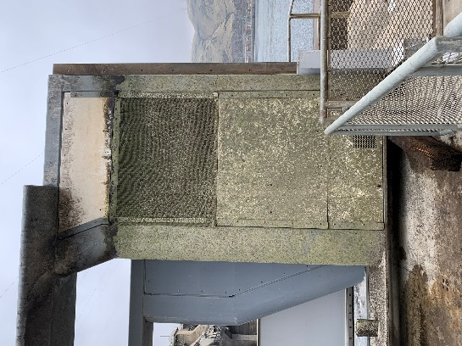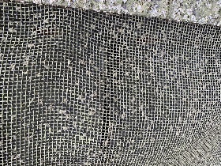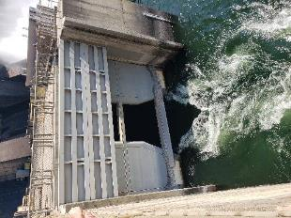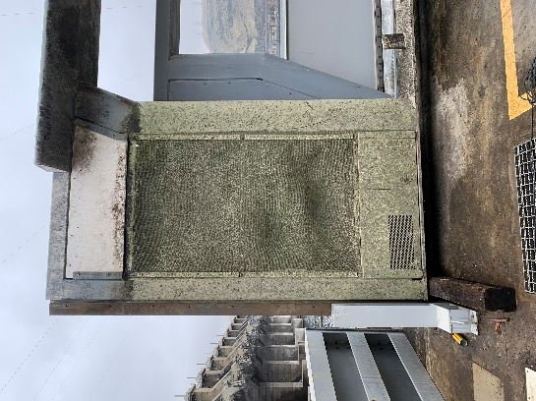

Project Schedule
Design: FY 2021
Construction: Winter 2021/2022
Evaluation/Closeout: FY 2022

Current Status
VWW is in place with JBS screen panels (as pictured above) awaiting design and fabrication.

Topics for FFDRWG Review/Coordination
None currently.

Fish Facility Design Review Work Group (FFDRWG)

USACE, Portland District

Project Update
Date Prepared/Updated: 2021-03-30

JDA North Fish Ladder LPS water supply upgrade
Project Identifier: | P2 # 492402
Project Manager (PM): | Eric Bluhm (CENWP-PM-FP)  Eric.V.Bluhm@usace.army.mil
Technical Lead (TL): | Adam White (CENWP-ENC)  Adam.J.White@usace.army.mil
FFDRWG Coordination (FC): | Jacob Macdonald (CENWP-PME)  Jacob.Macdonald@usace.army.mil

Project Description
Increase the capacity of the current system.
- Modify LPS to replace existing drop in well pumps with gravity-fed water supply or alternative, more reliable pump configuration.
- Larger collection box (current water supply is insufficient so larger box cannot be installed without upgraded water supply.
- Consider opportunities for volitional passage in the design (per 2020 CRS BA § 2.5, pg. 2-85)
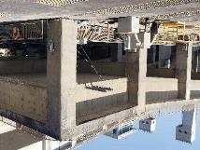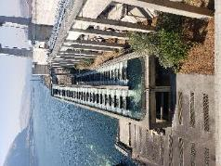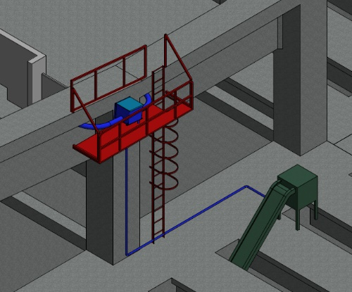

Project Schedule
Design: FY 2021
Construction: Winter 2021/2022
Evaluation/Closeout: FY 2022

Current Status
PDT will prepare multiple alternatives for consideration. Internal scoping meeting scheduled for 4/12. LPS is in service for 2021 passage season with existing pumps and collection box.

Topics for FFDRWG Review/Coordination
None currently.

Fish Facility Design Review Work Group (FFDRWG)

USACE, Portland District

Project Update
Date Prepared/Updated: 2021-03-02

JDA Turbine Rehab
Project Identifier: | P2 #
Project Manager (PM): | Steve Sipe (CENWP-PMF-P)  Steven.C.Sipe@usace.army.mil
Technical Lead (TL): | Curtis Lipski (CENWP-ENC-HD)  Curtis.L.Lipski@usace.army.mil
FFDRWG Coordination (FL): | Jon Rerecich (CENWP-PME)  Jonathan.G.Rerecich@usace.army.mil

Project Description
The purpose of this project is to address reliability concerns and maximize production of hydroelectric power at JDA, which includes electrical energy production and electrical grid ancillary services while at the same time, improving survival of fish passing through the turbines. Maximum production of hydroelectric power at JDA will be realized through increased reliability and increased efficiency. Reliability improvements will be realized through a combination of replacement and refurbishment of powertrain equipment to include, but not limited to, turbine runners, shafting, generators, isophase bus, breakers, switches, and transformers. Efficiency improvements will be realized through increased turbine efficiencies associated with new turbine runners and other modifications to the turbines.
The purpose of this project is also to increase survival of turbine passed fish. Increased survival of turbine passed fish will be realized through developing state-of-art hydroelectric turbines to obtain improved fish passage survival through the turbines. The design of the state-of-the-art turbines will be an iterative and collaborative process that focuses on fish-friendly design features and criteria. This iterative and collaborative design process will be similar to the ongoing Ice Harbor L&D turbine runner replacement design and upcoming McNary L&D turbine runner replacement in NWW. Phase 1A recommendations include replacing up to 14 units with combination fixed blade & adjustable blade to obtain improved fish passage survival through the turbines.

Project Schedule
Phase 1 Short Term Schedule | Start | Finish
30% DDR/P&S review | 3/12/2020 | 4/1/2020
60% DDR/P&S review | 8/28/2020 | 9/18/2020
90% DDR/P&S review | 9/21/2021 | 2/18/2022
BCOES review | 1/24/2022 | 11/11/2022

Overall Schedule Milestones | Date
Contract award | October 2024
Collaborative design process Model testing | 2024-2029
First unit installation | 2031-2033
Unit installation complete | 2040-2045

Current Status
- Final VE study report due Feb. 19, 2021

- The 1:25 scale physical observational turbine model rehab and relocation is complete. The model will be used to inform the development of the Phase 1 Plans and Specifications package, to document the hydraulic conditions that affect the biological performance of the existing JDA turbines, and to support the collaborative and iterative design process in Phase 2. ERDC baseline model validation testing with the existing runner has been scheduled for last week and this week. Baseline model data collection for Test Series 1 will be occurring until May 2021 at which time ERDC is scheduled to transition back to McNary. This task includes preparation of a data report documenting the runs performed, results, conclusions, and recommendations. Runner evaluation tests will need to carry over to Test Series 2 (not yet scoped), which is expected to occur in late 2021 or early 2022.

- Tailrace flow patterns have been validated in the 1:45 JDA general model and in a CFD model. Model runs will commence after further HAC modeling is complete and preliminary options for the turbine mix are established. The focus of the tailrace modeling will be to assess juvenile egress and conditions for adult approach to the fish ladder entrances.

Topics for FFDRWG Review/Coordination
None currently.

Fish Facility Design Review Work Group (FFDRWG)

USACE, Portland District

Project Update
Date Prepared/Updated: 2021-03-02

TDA AWS trash rake
Project Identifier: | P2 #
Project Manager (PM): | Ida Royer (CENWP-PMF)  Ida.M.Royer@usace.army.mil
Technical Lead (TL): | Erica Tarbox (CENWP-ENC)  Erica.M.Tarbox@usace.army.mil
FFDRWG Coordination (FC): | Ida Royer (CENWP-PMF)  Ida.M.Royer@usace.army.mil

Project Description

This project is to evaluate alternatives to remove debris from The Dalles Dam Auxiliary Water Supply (AWS) trash rack. Debris build-up on the rack currently causes high head differential across the rack.

Project Schedule
TBD

Current Status
New Startup. PM and TL have been assigned. Kickoff meeting and site visit are being scheduled and team members are being assigned.

Topics for FFDRWG Review/Coordination
None currently. PDT will solicit FFDRWG review during the Engineering Design Report (EDR) process.

Fish Facility Design Review Work Group (FFDRWG)

USACE, Portland District

Project Update
Date Prepared/Updated: 2021-03-30

BON Spillway Rock Removal [prevention]
Project Identifier: | P2 # 470163
Project Manager (PM): | Jeremiah Woodard (CENWP-PMF-P)  Jeremiah.J.Woodard@usace.army.mil
Technical Lead (TL): | Christopher Motti (CENWP-ENC-HD)  Christopher.S.Motti@usace.army.mil
FFDRWG Coordination (FC): | Andrew Derugin (CENWP-PME)  Andrew.G.Derugin@usace.army.mil

Project Description
This project is to determine whether a structural alternative can be identified to prevent rocks from moving into the stilling basin of Bonneville Dam. Currently emergency contracts are placed most years (four out of five since 2011) to physically remove rocks from the stilling basin. Alternatives will be evaluated based on factors such as their ability to prevent rock movement, cost, and ease of construction.

Project Schedule
A Phase 1a report is scheduled to be completed at the end of September 2021.

Current Status

30% phase 1a is complete and being reviewed by the PDT.

Topics for FFDRWG Review/Coordination
FFDRWG review of 30% phase 1a report will follow PDT review.

Fish Facility Design Review Work Group (FFDRWG)
USACE, Portland District
Project Update
Date Prepared/Updated: 2021-04-01

BON Second Powerhouse FGE
Project Identifier: | P2 #
Project Manager (PM): | Jim Adams (CENWP-PMF)  James.R.Adams@usace.army.mil
Technical Lead (TL): | Bridget Bell (CENWP-ENC)  Bridget.M.Bell@usace.army.mil
FFDRWG Coordination (FL): | Jon Rerecich (CENWP-PME)  Jonathan.G.Rerecich@usace.army.mil

Project Description
Steel plates were installed in all units in the A and B gatewells to restrict flow. During routine inspections, however, it became apparent that the anchoring system for the steel plates was inadequate. In effect, the nuts and anchoring bolts holding down the plates had come lose, posing the risk that the plates could detach and potentially take out a unit. All flow restriction plates were removed from the units.
A concrete corbel will be installed in the same location as the flow control plates with the design goal to achieve similar gatewell hydraulic conditions as the flow control plates. This new concrete corbel has been designed to meet the flow criteria established and tested for the previous flow restrictor plates to meet the hydraulic and biological goals.

Project Schedule
Awarded 21 December 2020 to Northbank Civil and Marine. Notice to proceed 29 December 2020.
CLIN | Status | Description | Award/Exercise Date | Construction Execution Window
1 | Mandatory | Mobilization/Demobilization | December 2020 Award
2 | Mandatory | Unit 15 Construction | December 2020 Award | February 2021-April 2021
3 | Optional | Second Mob/Demob and Unit 11 Construction | Sept. 30, 2021 | Dec 2021-Feb 2022
4 | Optional | 2 Additional Units | Sept. 30, 2021 | Extend through May 2022
5 | Optional | 2 Additional Units | Nov. 30, 2021 | Extend through August 2022
6 | Optional | 2 Additional Units (Unit 18 + 1 more Unit) | Nov. 30, 2021 | Extend through February 2023
Current Status
- Construction in unit 15 is underway and on track. Unit 15 is on the outage schedule March 1-April 20. The contract states the unit must be completed by April 15th.
- Hydraulic Testing Spring 2021 – During March contract negotiations with NWP, the A/E contractor expressed concerns in meeting the testing deadline and deliverables due to procurement of equipment, preparation/calibration of equipment, and staffing limitations. Hydraulic testing will not occur this year.
- Hydraulic tests will be needed next spring to meet the upper 1% test range of 18.0-18.5 kcfs.
- Impacts to the B2FGE concrete work contract are being evaluated. The concrete work will be delayed by one year.
- Rerecich owes Lorz a beer.

Topics for FFDRWG Review/Coordination
None currently.
.

Fish Facility Design Review Work Group (FFDRWG)

USACE, Portland District

Project Update
Date Prepared/Updated: 2021-03-30

BON Lamprey Passage Structure Pump Upgrade
Project Identifier: | P2 # 492400 (BON1) and 492401 (BON2)
Project Manager (PM): | Bob Winters (CENWP-PM-FP)  Robert.Winters@usace.army.mil
Technical Lead (TL): | Andrew Derugin (CENWP-ODB)  Andrew.G.Derugin@usace.army.mil
FFDRWG Coordination (FC): | Andrew Derugin (CENWP-PME)  Andrew.G.Derugin@usace.army.mil

Project Description
Bradford Island, Cascades Island, and Washington Shore LPS's will have current drop in well pumps replaced with standardized 480V surface mount pumps that will increase the reliability and flexibility of the Bonneville Dam LPS system.

Project Schedule
- Acquire Materials: FY 2021
- Installation: WA Shore and Cascades Island – FY 2021, Bradford Island – Winter 2021/2022
- Evaluation/Closeout: FY 2022

Current Status
Project staff are ordering pumps and will install them upon delivery.

Topics for FFDRWG Review/Coordination
None currently.

Fish Facility Design Review Work Group (FFDRWG)

USACE, Portland District

Project Update
Date Prepared/Updated: 2021-03-31

BON Cascades Island LPS Flume modifications
Project Identifier: | P2 # 492401
Project Manager (PM): | Bob Winters (CENWP-PM-FP)  Robert.Winters@usace.army.mil
Technical Lead (TL): | Adam White (CENWP-ENC)  Adam.J.White@usace.army.mil
FFDRWG Coordination (FC): | Andrew Derugin (CENWP-PME)  Andrew.G.Derugin@usace.army.mil

Project Description
Lamprey flume needs to be lowered to eliminate the mid-system lift pumps. This may require rerouting existing plumbing and moving electrical equipment in the area, as well as fabricating new brackets and a new flume section.
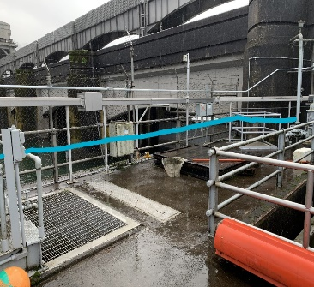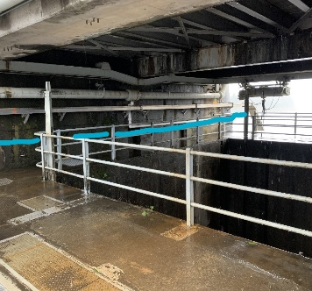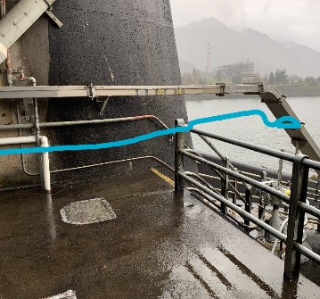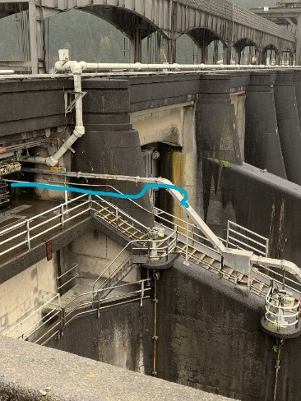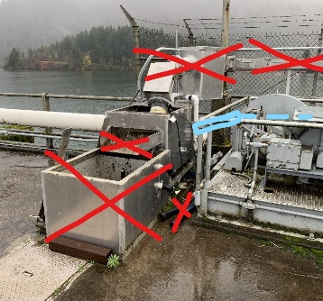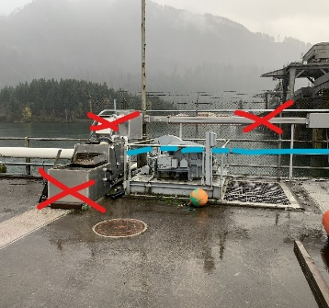

Project Schedule
- Design: FY 2021
- Construction: August 2021
- Evaluation and Closeout: FY 2022

Current Status
Initiating design.

Topics for FFDRWG Review/Coordination
None currently.

Fish Facility Design Review Work Group (FFDRWG)

USACE, Portland District

Project Update
Date Prepared/Updated: 2021-03-30

BON Cascades Island upper picketed lead modification
Project Identifier: | P2 # 492401
Project Manager (PM): | Bob Winters (CENWP-PM-FP)  Robert.Winters@usace.army.mil
Technical Lead (TL): | Andrew Derugin (CENWP-ODB)  Andrew.G.Derugin@usace.army.mil
FFDRWG Coordination (FC): | Andrew Derugin (CENWP-PME)  Andrew.G.Derugin@usace.army.mil

Project Description
Modify two upper picket leads (upstream of new LPS trap) to exclude lamprey from AWS Channel. Replace existing leads with smaller mesh and eliminate gaps to prevent lamprey from straying into the dead-end abandoned AWS channel.

Project Schedule
- Installation: FY 2021
- Evaluation/Closeout: FY 2021

Current Status
OD-B project staff are scheduled to perform this minor modification Spring 2021.

Topics for FFDRWG Review/Coordination
None currently.

Fish Facility Design Review Work Group (FFDRWG)

USACE, Portland District

Project Update
Date Prepared/Updated: 2021-03-31

BON Washington Shore control section redesign
Project Identifier: | P2 # 492401
Project Manager (PM): | Bob Winters (CENWP-PM-FP)  Robert.Winters@usace.army.mil
Technical Lead (TL): | Shari Dunlop (CENWP-ENC)  Shari.L.Dunlop@usace.army.mil
FFDRWG Coordination (FC): | Andrew Derugin (CENWP-PME)  Andrew.G.Derugin@usace.army.mil

Project Description
“…modify the serpentine-style flow control sections of Bonneville Dam’s Washington Shore and Bradford Island fish ladders, converting them to Ice Harbor-style vertical slot with submerged orifices configurations. This would improve passage conditions for adult lamprey and likely reduce stress and delay for adult salmon, steelhead, and bull trout. All full-duplex passive integrated transponder (PIT) arrays currently located in the control sections of these ladders would be replaced in kind or improved to maintain or enhance current levels of detection of PIT-tagged anadromous fish.”
-January 2020 CRS BA § 2.5, pg. 2-85.

Project Schedule
TBD

Current Status
A problem with PIT tag antennas coupled with actuated sill gates in the vertical slots was identified during scope development. The PDT is currently performing a screening-level investigation to determine if the required flow control can be achieved without adjustable-height sill gates. Based on the outcome, the design may include replacement of the PIT tag antennas in the control section or may require identifying an alternate location for the existing PIT tag antenna array.

Topics for FFDRWG Review/Coordination
None currently. PDT will coordinate with FFDRWG after we have a better understanding of the underlying design assumptions.
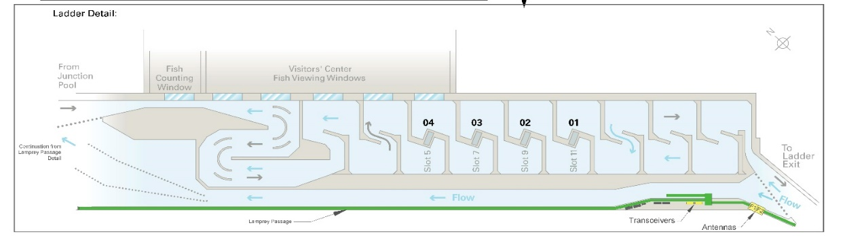

Fish Facility Design Review Work Group (FFDRWG)

USACE, Portland District

Project Update
Date Prepared/Updated: 2021-03-03

BON Bradford Island Ladder extensive minor modifications to serpentine section for lamprey
Project Identifier: | P2 # 492400
Project Manager (PM): | Bob Winters (CENWP-PM-FP)  Robert.Winters@usace.army.mil
Technical Lead (TL): | Adam White (CENWP-ENC)  Adam.J.White@usace.army.mil
FFDRWG Coordination (FC): | Andrew Derugin (CENWP-PME)  Andrew.G.Derugin@usace.army.mil

Project Description
Extensive minor modifications to control section (serpentine weirs) of ladder including refuge boxes, rounded corners on weirs, additional lamprey orifices, and (if practicable) new features such as artificial rocks.
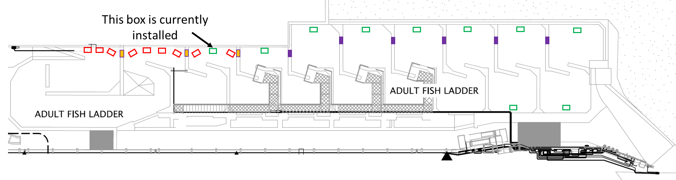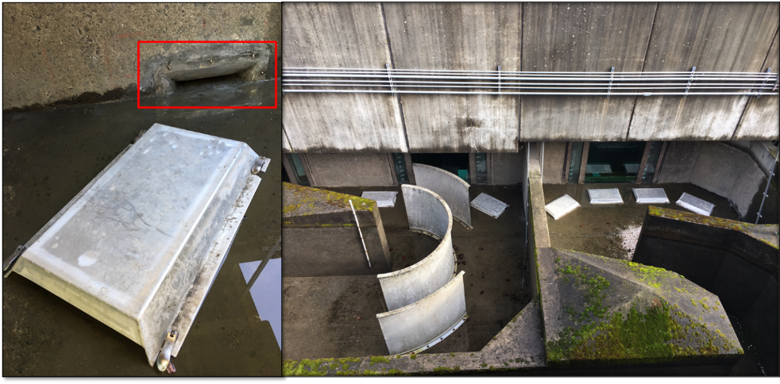

Project Schedule
TBD

Current Status
New Startup.

Topics for FFDRWG Review/Coordination
None currently.

Fish Facility Design Review Work Group (FFDRWG)

USACE, Portland District

Project Update
Date Prepared/Updated: 2021-03-03

BON Bradford Island B-Branch entrance improvements (variable width entrance weir, bollards, and transition pool LPS)
Project Identifier: | P2 # 492400
Project Manager (PM): | Bob Winters (CENWP-PM-FP)  Robert.Winters@usace.army.mil
Technical Lead (TL): | Adam White (CENWP-ENC)  Adam.J.White@usace.army.mil
FFDRWG Coordination (FC): | Andrew Derugin (CENWP-PME)  Andrew.G.Derugin@usace.army.mil

Project Description
Design B-Branch (Spillway) entrance improvements, including variable width weir, bollards, refuge boxes or other cover, as feasible. Implement in conjunction with transition pool LPS at this fishway.
- Modeled after Cascades Island and JDA North (mirror image of Cascades Island Entrance)
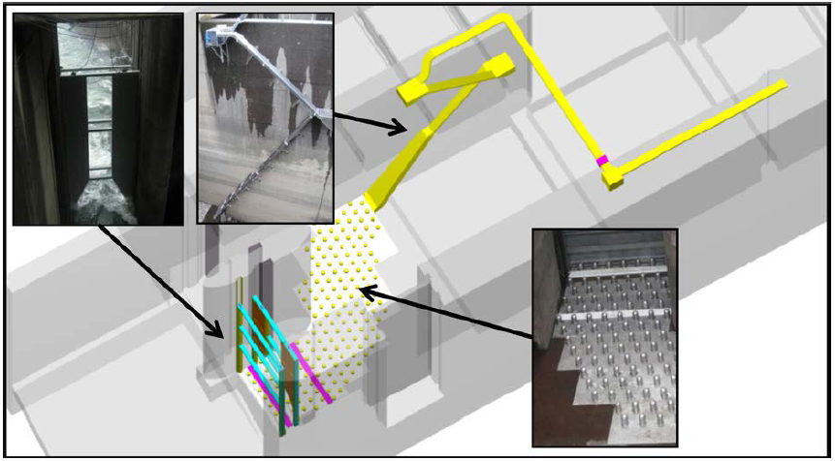
Cascades Island entrance improvements (2009)

Project Schedule
TBD

Current Status
Internal scoping meeting scheduled for 4/8.

Topics for FFDRWG Review/Coordination
None currently.

Fish Facility Design Review Work Group (FFDRWG)

USACE, Portland District

Project Update
Date Prepared/Updated: 2021-03-03

BON Washington Shore junction pool LPS
Project Identifier: | P2 # 492401
Project Manager (PM): | Bob Winters (CENWP-PM-FP)  Robert.Winters@usace.army.mil
Technical Lead (TL): | Adam White (CENWP-ENC)  Adam.J.White@usace.army.mil
FFDRWG Coordination (FC): | Andrew Derugin (CENWP-PME)  Andrew.G.Derugin@usace.army.mil

Project Description
Design Transition Pool LPS to tailrace deck collection box. Include refuge boxes or bollards to guide lamprey to new structure.
“Expand network of Lamprey Passage Structures (LPSs) to bypass impediments in existing fish ladders (Lamprey Passage Structures). Ramp-like flume structures would be installed or modified in fish ladders at Bonneville, The Dalles, and John Day dams to guide adult lamprey out of fish ladders and into parallel systems for volitional passage or collection for upstream transport or passage studies. The LPSs would use independent water sources (pumps or gravity flow
systems) and may be placed in various locations within fish ladders, such as collection channels, junction pools, and auxiliary water supply channels. New structures may be installed at Bonneville Dam’s Bradford Island and Washington Shore fish ladders, The Dalles Dam’s east fish ladder, and/or John Day Dam’s south fish ladder. At John Day Dam, the existing lamprey passage structure on the north fish ladder may be extended from the tailrace deck to the forebay”
-January 2020 CRS BA § 2.5, pg. 2-85.

Project Schedule
- Design: FY 2021 – FY 2022
- Construction: Winter 2022/2023
- Evaluation/Closeout: FY 2023

Current Status
New Startup.

Topics for FFDRWG Review/Coordination
None currently.

Fish Facility Design Review Work Group (FFDRWG)

USACE, Portland District

Project Update
Date Prepared/Updated: 2021-03-30

TDA East Fish Ladder junction pool LPS
Project Identifier: | P2 # 492403
Project Manager (PM): | Eric Bluhm (CENWP-PM-FP)  Eric.V.Bluhm@usace.army.mil
Technical Lead (TL): | Adam White (CENWP-ENC)  Adam.J.White@usace.army.mil
FFDRWG Coordination (FC): | Jacob Macdonald (CENWP-PME)  Jacob.Macdonald@usace.army.mil

Project Description
Design junction pool LPS to tailrace deck collection box.
“Expand network of Lamprey Passage Structures (LPSs) to bypass impediments in existing fish ladders (Lamprey Passage Structures). Ramp-like flume structures would be installed or modified in fish ladders at Bonneville, The Dalles, and John Day dams to guide adult lamprey out of fish ladders and into parallel systems for volitional passage or collection for upstream transport or passage studies. The LPSs would use independent water sources (pumps or gravity flow
systems) and may be placed in various locations within fish ladders, such as collection channels, junction pools, and auxiliary water supply channels. New structures may be installed at Bonneville Dam’s Bradford Island and Washington Shore fish ladders, The Dalles Dam’s east fish ladder, and/or John Day Dam’s south fish ladder. At John Day Dam, the existing lamprey passage structure on the north fish ladder may be extended from the tailrace deck to the forebay” -January 2020 CRS BA § 2.5, pg. 2-85.

Project Schedule
- Design: FY 2021 – FY 2022
- Construction: Winter 2022/2023
- Evaluation/Closeout: FY 2023

Current Status
New startup. Internal scoping meeting scheduled for 4/21.

Topics for FFDRWG Review/Coordination
None currently.

Fish Facility Design Review Work Group (FFDRWG)

USACE, Portland District

Project Update
Date Prepared/Updated: 2021-03-03

TDA East Fish Ladder control section weir modifications for lamprey
Project Identifier: | P2 # 492403
Project Manager (PM): | Eric Bluhm (CENWP-PM-FP)  Eric.V.Bluhm@usace.army.mil
Technical Lead (TL): | Adam White (CENWP-ENC)  Adam.J.White@usace.army.mil
FFDRWG Coordination (FC): | Jacob Macdonald (CENWP-PME)  Jacob.Macdonald@usace.army.mil

Project Description
Modify elevated orifices in East Fish Ladder control section weirs 154-157 for better adult lamprey passage.

Project Schedule
- Design: FY 2022
- Construction: Winter 2022/2023
- Evaluation/Closeout: FY 2023

Current Status
New Startup.

Topics for FFDRWG Review/Coordination
None currently.

Fish Facility Design Review Work Group (FFDRWG)

USACE, Portland District

Project Update
Date Prepared/Updated: 2021-03-30

JDA South Ladder entrance improvements (rounded crest, slot filler)
Project Identifier: | P2 # 492402
Project Manager (PM): | Eric Bluhm (CENWP-PM-FP)  Eric.V.Bluhm@usace.army.mil
Technical Lead (TL): | Adam White (CENWP-ENC)  Adam.J.White@usace.army.mil
FFDRWG Coordination (FC): | Jacob Macdonald (CENWP-PME)  Jacob.Macdonald@usace.army.mil

Project Description
Entrance weir improvements (rounded crest, slot filler). Caps cannot be added to South Ladder entrance weir due to FPP submergence criteria so the weir needs to be modified more extensively to provide rounded weir crests and guide slot covers.

Project Schedule
- Design: FY2021
- Construction: Winter 2021/2022
- Evaluation/Closeout: FY 2022

Current Status
Internal scoping meeting scheduled for 4/12.

Topics for FFDRWG Review/Coordination
None currently.

